**Applied Industrial Internet of Things**

Configuration of Address Resolution Protocol (ARP)

Problem Description:

While Developing ARP for Wireless LAN identify what are the challenge you anticipate Represent them as Mindmap

Task Details:

Choose And Create the Mindmap template in Lucid Chart:

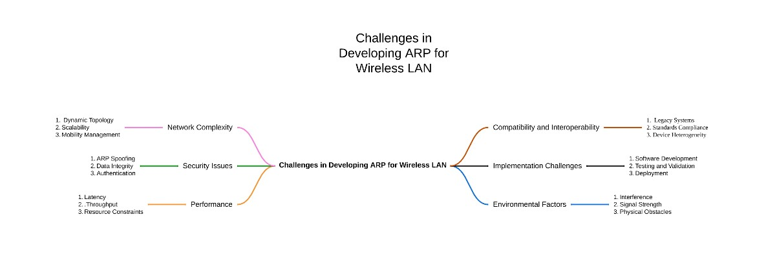

1. Network Complexity:

* Dynamic Topology: Frequent changes in network configuration.
* Scalability: Handling a large number of devices efficiently.
* Mobility Management: Dealing with mobile devices moving across network zones.

1. Security Issues:

* ARP Spoofing: Risk of malicious devices sending false ARP messages.
* Data Integrity: Ensuring data is not tampered with during transmission.
* Authentication: Verifying the identity of devices.

1. Performance:

* Latency: Ensuring low latency for real-time communication.
* Throughput: Maintaining high data transfer rates.
* Resource Constraints: Managing limited bandwidth and processing power.

1. Compatibility and Interoperability:

* Legacy Systems: Ensuring compatibility with existing network infrastructure.
* Standards Compliance: Adhering to industry standards and protocols.
* Device Heterogeneity: Supporting a variety of devices with different capabilities.

1. Implementation Challenges:

* Software Development: Writing efficient and error-free code.
* Testing and Validation: Comprehensive testing to ensure reliability.
* Deployment: Smooth deployment without disrupting existing services.

1. Environmental Factors:

* Interference: Managing interference from other wireless devices.
* Signal Strength: Ensuring consistent and adequate signal strength.
* Physical Obstacles: Overcoming barriers like walls and furniture.